Ideation Phase
Define the Problem Statements

Date | 01 November 2025
Team ID | NM2025TMID00449
Project Name | Laptop Request Catalog Item
Maximum Marks | 2 Marks

Customer Problem Statement Template

Employees and IT teams currently face delays and manual errors when requesting laptops. The existing process lacks a user-friendly digital request system, resulting in incomplete information, slow fulfillment, and frustrated staff. Without dynamic forms, requests are often returned for clarification, and IT admins have difficulty tracking hardware needs and update histories.
They need a simple, automated platform to request laptops and accessories with all required fields, guidance, and real-time validation—ensuring faster, accurate service delivery and improved asset management.
This solution, delivered as a ServiceNow Service Catalog item with dynamic UI policies and automation, will improve operational efficiency and employee satisfaction.

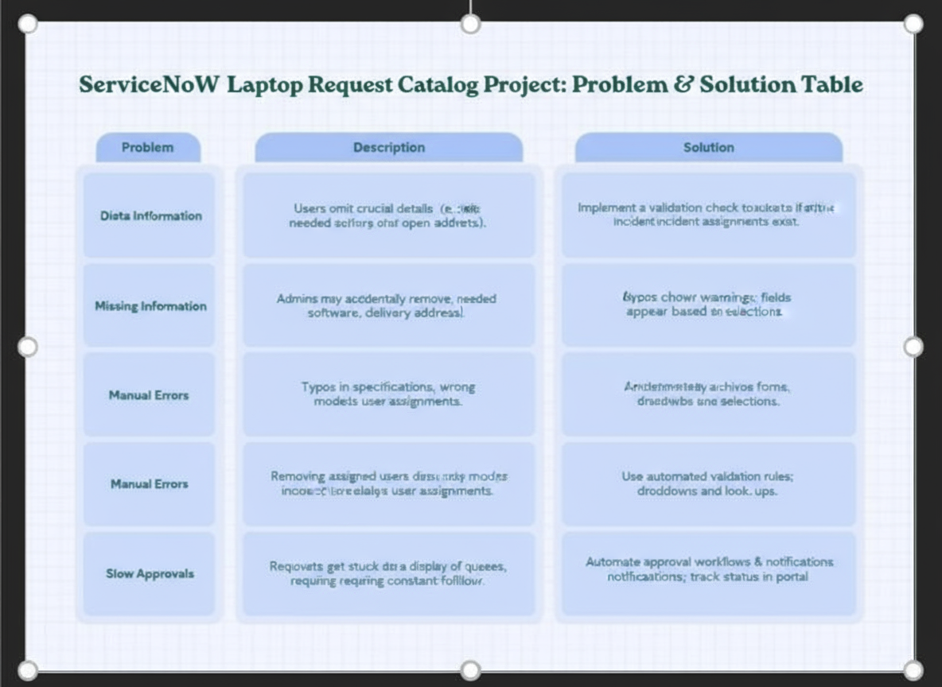
Example:

Problem Statement (PS) | I am (User) | I want to | But | Because | Which makes me feel
PS-1 | An employee | request a laptop online | the form is confusing and often returned | required accessory details are missing | frustrated and dissatisfied
PS-2 | IT Admin | track laptop requests efficiently | missing or incomplete request details slow down approval | manual review wastes time | stressed and overwhelmed

Detailed Problem Statements

PS-1:
As an employee, I am trying to request a laptop for my daily work, but the form does not guide me clearly. Missing data or incorrect accessory choices often means IT must contact me or reject my request. This slows me down and makes me feel frustrated.
I need an easy, guided digital form to make my laptop request quickly, with all fields validated and options shown only when relevant.

PS-2:
As an IT administrator, I want to fulfill laptop requests smoothly. But incomplete or unclear requests result in manual review and inefficient communication. This increases workload, delays fulfillment, and reduces service quality.
I need a dynamic request system that ensures all details are captured, reducing errors, speeding approvals, and improving tracking of hardware assets.

Reference:
You can adapt examples and tables from templates like miro.com problem statement template for your documentation.

